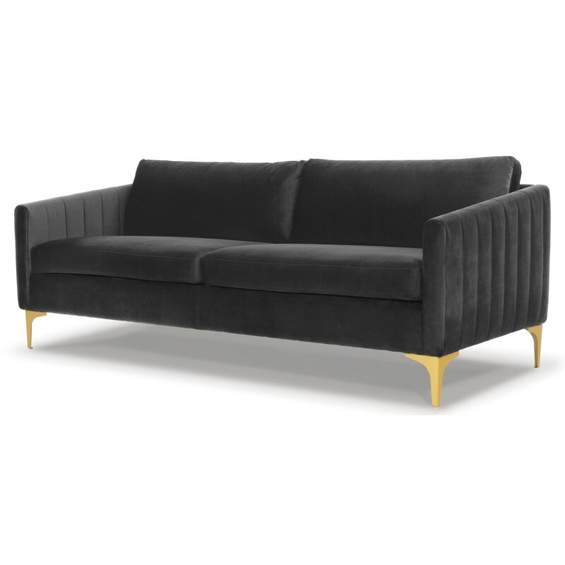

Laci 81'' Velvet Sofa
Rated 4.6 out of 5 stars.
4.630 Reviews
$940
$79/mo. for 12 mos - Total $940¹ with an AllModern credit card
Free Shipping
Get it in 2-3 weeks
Ship To:
67346 - Grenola

Fabric:

Dark Gray
Dark Gray
Navy Blue
Rust is out of stock
Cream is out of stock
Emerald Green is out of stock
Select QuantityMinusPlus
Save this item to your list
Add to Cart

What We Offer

Full Service Delivery + Assembly (Limited Contact)
Available in checkout for $119.99.
Full Service Delivery + Assembly (Limited Contact)Learn More

Product Details
Solid Wood
Reversible Cushions
Removable Seat Cushions
Removable Back Cushions
Solid Wood
Seat Depth: Standard (21"-28")
Seat Height (inches): 18.5
Weight Capacity (lbs): 1000
Commercial Use: Yes
Features: Tear Resistant
- Seats 3
- Seat Depth
Standard (21"-28")
- Commercial Use
No
- Overall Depth
35 ''
- Overall Height
31 ''
- Overall Width
81 ''
- Description
Drawing on retro designs, this sofa pairs its clean-lined silhouette with bold channel tufting on the arms for a truly iconic look. It's made with a solid wood frame, and has a resilient velvet upholstery. That upholstery is designed to resist fading, tears, and stains, so it can hold up to regular use. Plus, with sinuous springs and a blend of synthetic fiber and foam filling, it's both supportive and plush. And with tapering track arms and gold-finished bracket feet to go with the channel tufting, its definitely a mid-century statement piece.

Features
  - Sustainable, kiln-dried hardwood to prevent warping
  - Ideal for TV rooms, living rooms, entertainment rooms
  - Seat platform coil suspension enhances comfort and resists sagging
  - Thick medium-firm and comfortable cushion made from three layers of eco-friendly medium density foam with loose fibers
  - Arrives fully assembled, just attach the legs
  - just attach the legs

Product Details
  - Leg Material: Metal
  - Cushion Construction: Fiber Wrapped Foam
  - Design: Standard
  - Weight Capacity: 1000 lb.
  - Adult Assembly Required: Yes
See More

