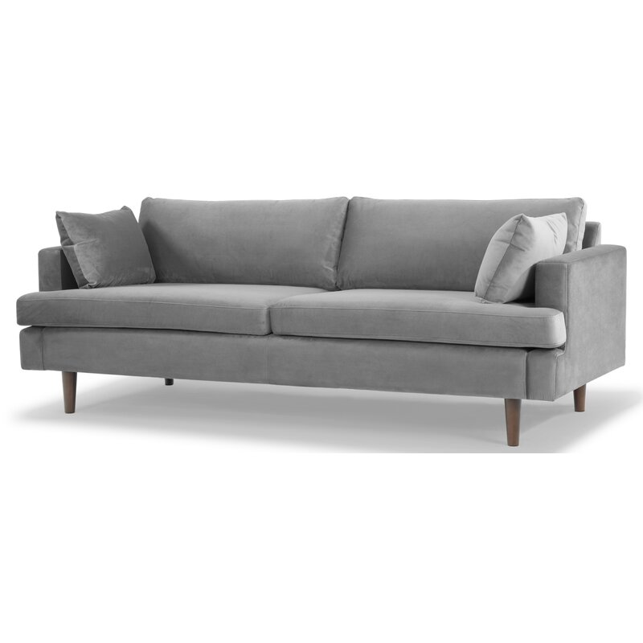

Laguna 83'' Velvet Sofa
Rated 4.75 out of 5 stars.
4.851 Reviews
$930$1,180.9921% Off

On Sale
$78/mo. for 12 mos - Total $930¹ with an AllModern credit card
Only 3 Left in Stock. Buy Soon!
Free Shipping
Get it between Mon, Sep 27 - Mon, Oct 4
Ship To:
67346 - Grenola

Fabric:

Light Gray
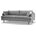
Light Gray
Cream
Navy Blue is out of stock
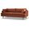
Rust is out of stock
Select QuantityMinusPlus
Save this item to your list
Add to Cart

What We Offer

Full Service Delivery + Assembly (Limited Contact)
Available in checkout for $119.99.
Full Service Delivery + Assembly (Limited Contact)Learn More

Product Details
Solid Wood
Removable Seat Cushions
Removable Back Cushions
Solid Wood
Seat Depth: Standard (21"-28")
Seat Height (inches): 18.5
Weight Capacity (lbs): 1000
Features: Tear Resistant
- Seats 3
- Seat Depth
Standard (21"-28")
- Commercial Use
No
- Overall Depth
35 ''
- Overall Height
31 ''
- Overall Width
83 ''
- Description
Recessed arms, tapered dowel legs, and a clean-lined silhouette give this sofa an unmistakably mid-century look. But our favorite thing about it? The way it's designed to hold up to regular use. It's made with a solid wood frame, and is upholstered in a polyester velvet fabric. That fabric can resist stains, tears, and water, so you can kick back day after day without worrying. Sinuous spring seat construction and foam and synthetic fiber filling add the right balance of padding and cushioning. This piece requires 26'' of doorway clearance.

What's Included?
  - Toss Pillow

Features
  - Sustainable, kiln-dried to prevent warping
  - Ideal for TV rooms, living rooms, entertainment rooms
  - Seat platform coil suspension enhances comfort and resists sagging
  - Thick medium firm and comfortable cushion made from three layers of eco-friendly medium density foam with loose fibers
  - just attach the legs

Product Details
  - Leg Material: Solid Wood
  - Cushion Construction: Fiber Wrapped Foam
  - Design: Standard
  - Weight Capacity: 700 lb.
  - Adult Assembly Required: Yes
See More

