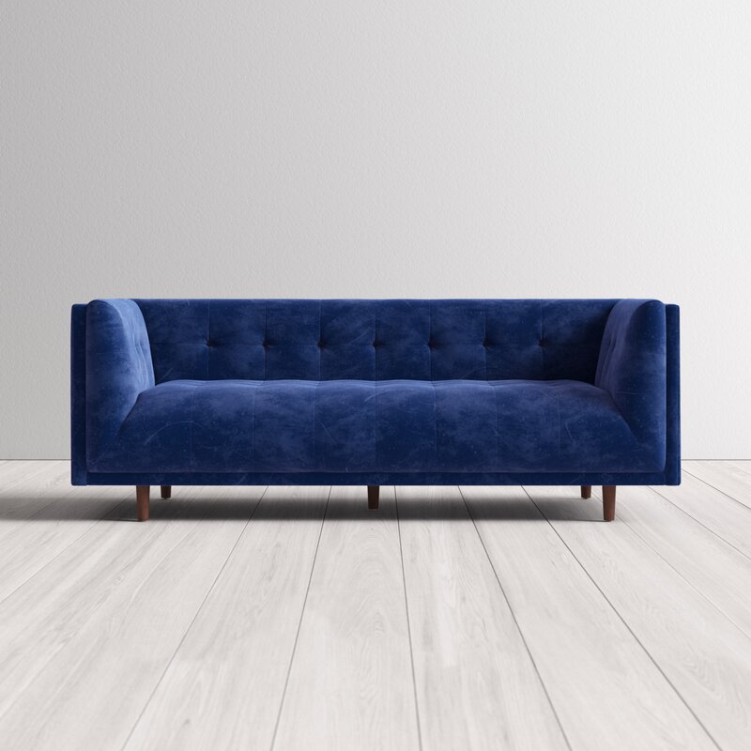

Jayda 82'' Velvet Sofa
Rated 4.6 out of 5 stars.
4.61010 Reviews
$700$1,35048% Off

On Sale
$59/mo. for 12 mos - Total $700¹ with an AllModern credit card
Only 6 Left in Stock. Buy Soon!
Free Shipping
Get it between Thu, Sep 30 - Thu, Oct 7
Ship To:
67346 - Grenola
Shopping for a business? Unlock insider pricing

Fabric:

Sapphire Velvet
Sapphire Velvet
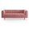
Blush Velvet
Copen Blue Velvet is out of stock
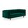
Emerald Velvet is out of stock
Olive Green Velvet is out of stock
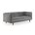
Platinum Velvet is out of stock
Select QuantityMinusPlus
Save this item to your list
Add to Cart

What We Offer

Full Service Delivery + Assembly (Limited Contact)
Available in checkout for $119.99.
Full Service Delivery + Assembly (Limited Contact)Learn More

Product Details
Solid Wood
Solid Wood
Seat Depth: Standard (21"-28")
Seat Height (inches): 18
Weight Capacity (lbs): 750
- Seats 4
- Seat Depth
Standard (21"-28")
- Commercial Use
No
- Features
Low
- Overall Depth
32 ''
- Overall Height
30 ''
- Overall Width
82 ''
- Description
An eye-catching design with a vintage vibe, this streamlined Chesterfield sofa anchors your living room layout in statement-making style. Founded atop conical legs in a warm pecan finish, its wooden frame is padded with foam and upholstered with polyester velvet fabric for a design that promotes a medium seating firmness. Though its clean lines and solid hue may seem understated at first, tufted details complete the look with a tasteful touch of texture. Assembly is required.

Product Details
  - Leg Material: Solid Wood
  - Design: Standard
  - Weight Capacity: 750 lb.
  - Adult Assembly Required: Yes
See More

