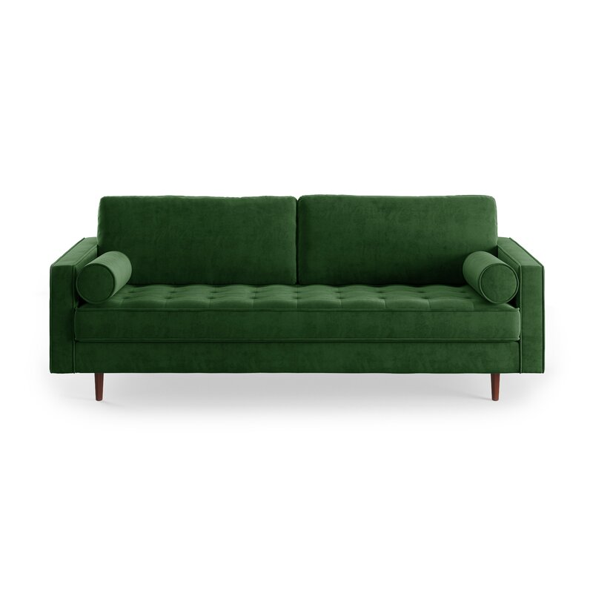

Lark 84'' Sofa
Rated 4.7 out of 5 stars.
4.74281 Reviews
$830$1,35039% Off

On Sale
$70/mo. for 12 mos - Total $830¹ with an AllModern credit card
Free Shipping
Get it between Sat, Oct 2 - Sat, Oct 9
Ship To:
67346 - Grenola

Fabric:

Emerald Green Velvet
Emerald Green Velvet
Beige Fabric
Blush Pink Velvet
Copen Blue Velvet
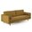
Gold Velvet
Grey Fabric
+ 4
Select QuantityMinusPlus
Save this item to your list
Add to Cart

What We Offer

Full Service Delivery + Assembly (Limited Contact)
Available in checkout for $119.99.
Full Service Delivery + Assembly (Limited Contact)Learn More

Product Details
Solid Wood
Removable Seat Cushions
Removable Back Cushions
Solid Wood
Seat Depth: Standard (21"-28")
Seat Height (inches): 18
Weight Capacity (lbs): 700
- Seats 3
- Seat Depth
Standard (21"-28")
- Commercial Use
No
- Overall Depth
37 ''
- Overall Height
34 ''
- Overall Width
84 ''
- Description
A stylish sofa is an easy way to elevate the entire look of your room – and this sofa is the perfect candidate for the job. Upholstered in plush velvet and supported by a sturdy wood frame, it features a button-tufted seat for a touch of tailored detail. Both the seat and back cushions are filled with foam for a more comfortable lounging experience, and are secured to the frame so you never have to worry about them shifting out of place. Slim, tapered legs made from pecan wood give just the right amount of warmth to the look, and both bolster pillows are included.

What's Included?
  - Toss Pillow

Product Details
  - Leg Material: Solid Wood
  - Cushion Construction: Foam
  - Design: Standard
  - Weight Capacity: 700 lb.
  - Adult Assembly Required: Yes
See More

