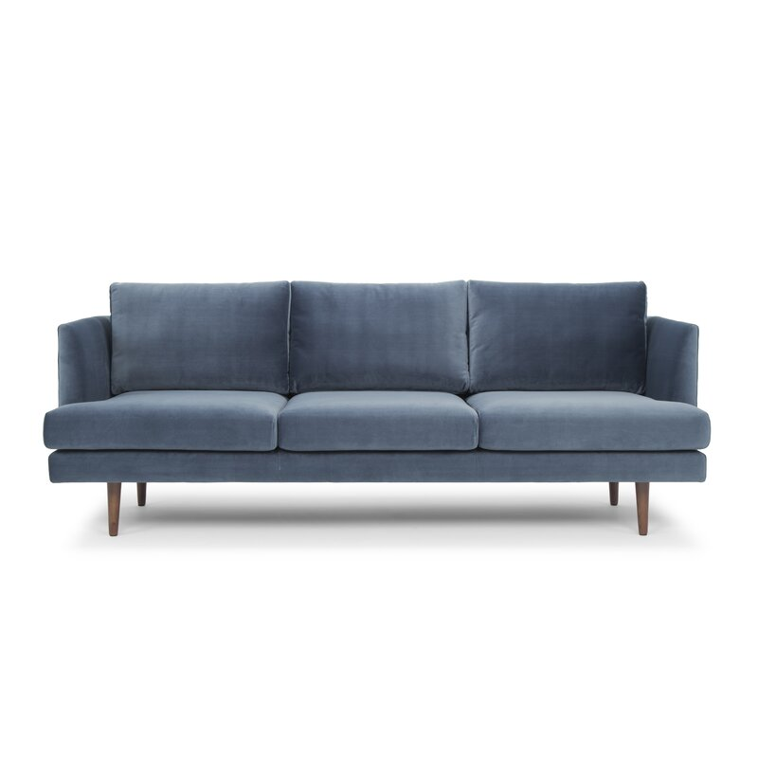

Jase 84'' Velvet Sofa
Rated 4.7 out of 5 stars.
4.7598 Reviews
$1,100$1,59931% Off
$92/mo. for 12 mos - Total $1,100¹ with an AllModern credit card
Free Shipping
Get it in 2-3 weeks
Ship To:
67346 - Grenola
Shopping for a business? Unlock insider pricing
Top of Form
Fabric:

Stax Dust Blue
Stax Dust Blue
Stax Dark Blue
Stax Rust
Stax Light Gray
Stax Koks Dark Gray
Boucle White
Boucle Dark Gray
Free Samples
Select QuantityMinusPlus
Save this item to your list
Add to Cart
Bottom of Form

What We Offer

Full Service Delivery + Assembly (Limited Contact)
Available in checkout for $119.99.
Full Service Delivery + Assembly (Limited Contact)Learn More

Product Details
Removable Seat Cushions
Removable Back Cushions
Lifetime Warranty
Seat Depth: Standard (21"-28")
Seat Height (inches): 18.5
Weight Capacity (lbs): 500
Commercial Use: Yes
- Seats 3
- Seat Depth
Standard (21"-28")
- Commercial Use
No
- Overall Depth
34.6 ''
- Overall Height
31.88 ''
- Overall Width
84 ''
- Description
The anchor of any living room, sofas are central for both giving everyone a seat during a movie marathon or game night, while also tying together your space's look. So if you're looking to put together a room with a modern touch, try a sofa like this! Crafted with a solid wood frame, this piece features recessed arms, a streamlined silhouette, and tapered dowel feet for a mid-century-inspired contemporary look. Foam and fiber filling gives the cushions an inviting feel, while polyester velvet allows this sofa to be easily added to a variety of color schemes.

Features
  - Designed and manufactured by SOFACOMPANY

Product Details
  - Leg Material: Manufactured Wood
  - Cushion Construction: Fiber Wrapped Foam
  - Design: Standard
  - Weight Capacity: 500 lb.
  - Adult Assembly Required: Yes
See More

