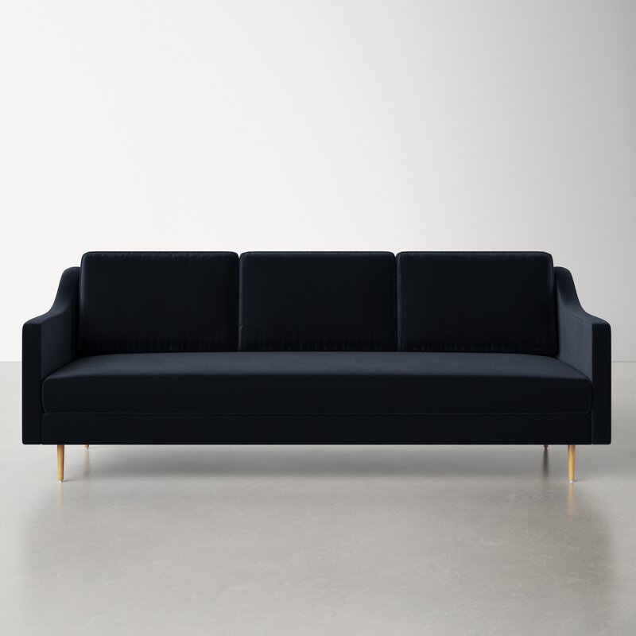

Haskin 90.5'' Velvet Sofa
Rated 4.75 out of 5 stars.
4.742 Reviews
$1,200$1,480.9919% Off
$100/mo. for 12 mos - Total $1,200¹ with an AllModern credit card
Free Shipping
Get it in 3-4 weeks
Ship To:
67346 - Grenola
Top of Form
Upholstery Color:

Black
Black
Gray is out of stock
Select QuantityMinusPlus
Save this item to your list
Add to Cart
Bottom of Form

What We Offer

Full Service Delivery + Assembly (Limited Contact)
Available in checkout for $119.99.
Full Service Delivery + Assembly (Limited Contact)Learn More

Product Details
Solid Wood
Removable Seat Cushions
Removable Back Cushions
Solid Wood
Seat Depth: Standard (21"-28")
Seat Height (inches): 19
Made Clean
Weight Capacity (lbs): 800
- Seats 3
- Seat Depth
Standard (21"-28")
- Commercial Use
No
- Overall Depth
35 ''
- Overall Height
33.8 ''
- Overall Width
90.5 ''
- Description
Rich with glam vibes that call to mind the Golden Era of Hollywood, this sofa is an undeniable stunner. Its sloped track arms and single-seat cushion offer clean lines that are echoed in the seaming and thin tapered legs. (No matter what sofa color you choose, the gold finish on the metal legs is guaranteed to grab attention.) Soft velvet gives the design a luxe look and feel, and the cushions are filled with foam and supported by sinuous springs for your comfort. Both the seat and back cushions are removable to make readjusting and cleaning a breeze.

Features
  - Handmade by skilled furniture craftsmen
  - Fabric swatch available

Product Details
  - Leg Material: Metal
  - Cushion Construction: Fiber Wrapped Foam
  - Design: Standard
  - Weight Capacity: 800 lb.
  - Adult Assembly Required: Yes
See More

