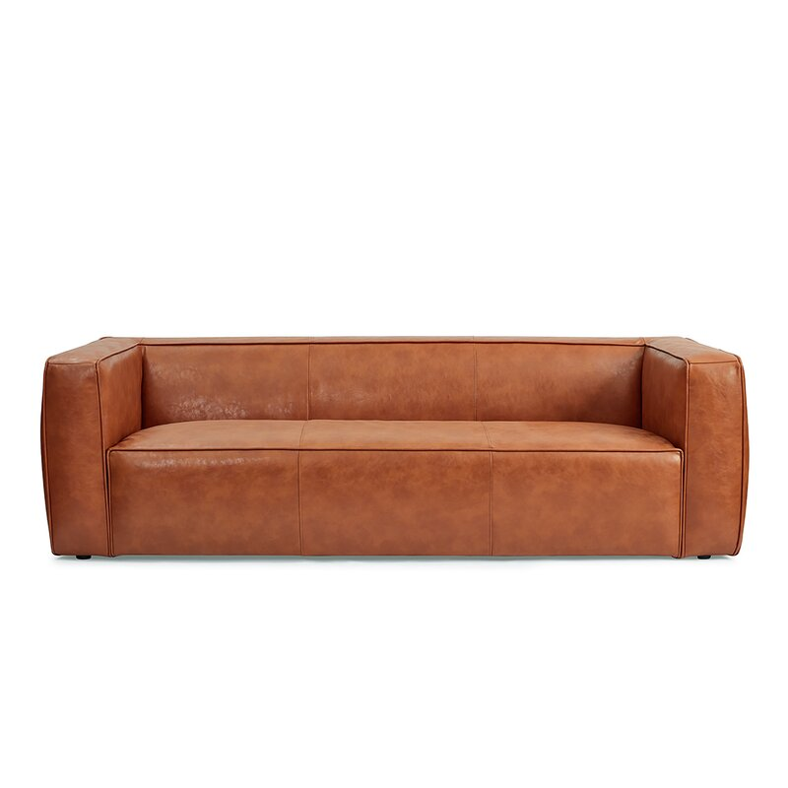

Niccolo 88'' Genuine Leather Sofa
Rated 4.65 out of 5 stars.
4.646 Reviews
$1,950
$109/mo. for 18 mos - Total $1,950¹ with an AllModern credit card
Free Shipping
Get it in 2-3 weeks
Ship To:
67346 - Grenola
Top of Form
Select QuantityMinusPlus
Save this item to your list
Add to Cart
Bottom of Form

What We Offer

Full Service Delivery + Assembly (Limited Contact)
Available in checkout for $119.99.
Full Service Delivery + Assembly (Limited Contact)Learn More

Product Details
Genuine Leather
Seat Depth: Extra Deep (over 35")
Seat Height (inches): 15
Weight Capacity (lbs): 800
- Seats 3
- Seat Depth
Extra Deep (over 35")
- Commercial Use
No
- Features
Low
- Overall Depth
37 ''
- Overall Height
26 ''
- Overall Width
88 ''
- Description
After a long day at work, sometimes all you want to do is a sofa flop. So, why not sofa flop in style on this leather sofa. Built on a solid engineered wood frame, the couch features track arms with tight seat and back cushions to create a streamlined silhouette. The genuine top-grain-leather upholstery is foam-filled with integrated springs in the seat for just the right amount of give as you flop. Vertical stitch detailing along the back, seat, and arms provide a stylish finishing touch.

Features
  - Corner-blocked frame

Product Details
  - Leg Material: Plastic
  - Cushion Construction: Foam
  - Design: Standard
  - Weight Capacity: 800 lb.
  - Adult Assembly Required: No
See More

