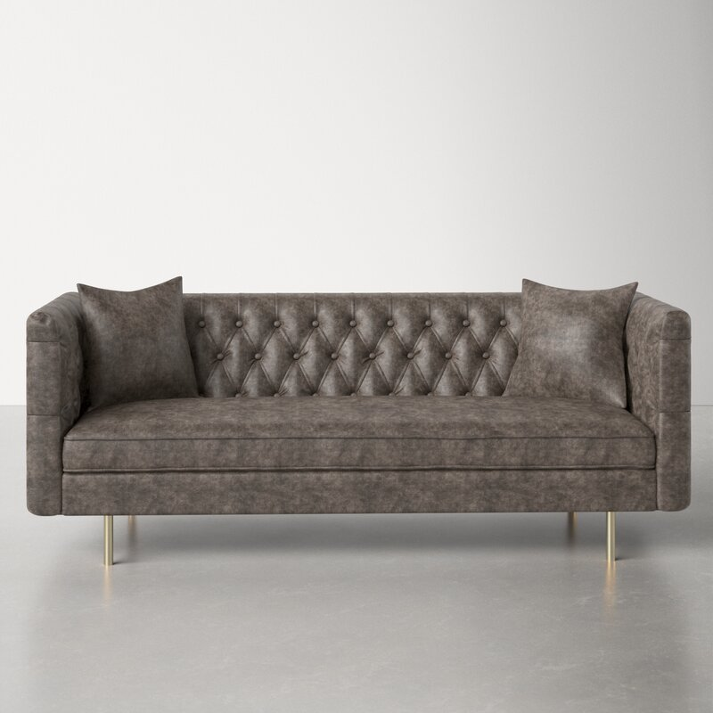

Jenkin 79'' Chesterfield Sofa
Rated 4.6 out of 5 stars.
4.6173 Reviews
$1,030$1,31722% Off

On Sale
$86/mo. for 12 mos - Total $1,030¹ with an AllModern credit card
Only 2 Left in Stock. Buy Soon!
Free Shipping
Get it in 2-3 weeks
Ship To:
67346 - Grenola

Fabric:

Vintage Gray Faux Leather
Vintage Gray Faux Leather
Honey Tan Faux Leather is out of stock
Select QuantityMinusPlus
Save this item to your list
Add to Cart

What We Offer

Full Service Delivery + Assembly (Limited Contact)
Available in checkout for $119.99.
Full Service Delivery + Assembly (Limited Contact)Learn More

